The Joy Factory, Inc

9351 Irvine Blvd  
 Irvine, CA 92618  
  
 T: 949.216.8888

F: 949.216.8889

www.**thejoyfactory**.com

**FOR IMMEDIATE RELEASE**

**MEDIA CONTACT:** Christine Welch

Echo Media Group

714-573-0899 ext. 225

[christine@echomediapr.com](mailto:christine@echomediapr.com)

**THE JOY FACTORY LAUNCHES AXTION™ GO LINE OF IPHONE 5 SLIM, YET UNUSUALLY DURABLE CASES**

***--aXtion Go Cases Meet Industry’s Water-Resistant Ratings & Military Grade Shockproof Standards--***

**IRVINE, Calif. (June 4, 2013)** – Just in time for summer, [The Joy Factory, Inc.](http://www.thejoyfactory.com) today launched [aXtion™ Go](http://www.thejoyfactory.com/products/axtion-go), a light-weight yet protective line of cases for the iPhone 5. Building on the company’s success of versatile and sturdy cases for iOS devices, The Joy Factory has incorporated advanced Diamond Air Cushion™ technology to offer one of the slimmest, yet most durable cases on the market that meets both military-grade shockproof and IP65 water-resistant and dust-proof standards.

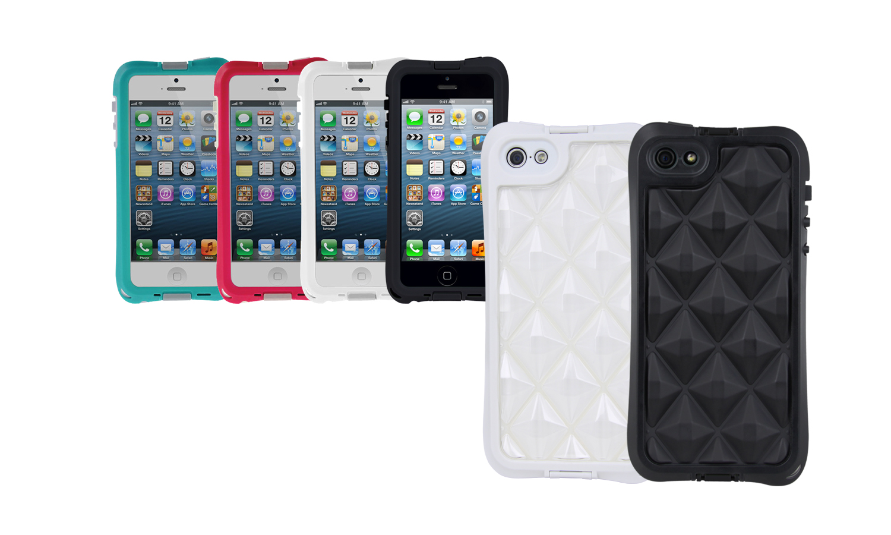“Our new aXtion Go case line is ideal for iPhone 5 users who lead an active lifestyle but don’t want a bulky case to weigh them down,” said Miranda Su, executive vice president of The Joy Factory. “We set out to create the ultimate durable case. It protects against the most destructive natural elements and human mishaps to iPhones --water, mud, snow, drops and scratches-- yet remains stylish, light and slim.”

[aXtion Go for the iPhone 5](http://www.thejoyfactory.com/products/axtion-go)

The aXtion Go case for iPhone 5 boasts a thin profile measuring less than one half-inch thick, helping to make it one of the slimmest cases to offer significant shockproof protection. The diamond-shaped air cushions work with four layers of built-in protection to guard the iPhone against routine bumps, drops and scrapes without adding any unnecessary weight or bulk to the case.

“The design of the aXtion Go was based on customer feedback and industry dataanalyzed on the common mishaps that users have with their phones in everyday life. Among those surveyed(1) 59 percent of male users ranked the garage as the most frequent household spot where they damaged their smartphone and for women, 41 percent noted the bathroom as the common spot for phone incidents,” added Su. “In response, The Joy Factory has introduced a case that meets the highest military-grade shockproof standards and offers everyday protection and for home and work-life phone calamities.”

-more-

**The Joy Factory Introduces aXtion Go – page 2**

The aXtion Go case meets the IP65 water-resistant standard, meaning it can withstand brief submersion in water and is protected against airborne particles such as dirt and dust. The durable case also meets the highest standard of military-grade shockproof MIL-STD-810, which helps safeguard the iPhone 5 from accidental drops. In addition, aXtion Go offers a number of features including:

* Built-in SureGuard™ heavy-duty screen protector optimized for texting and touchscreen navigation .
* Intelli-Filter™ Technology that blocks water, not sound, for clearer calls and impressive music playback.
* Sharpvue™ Camera Lens that protects the iPhone’s camera without degrading picture quality.
* Removable Hand Strap for added convenience.

**Accessory Line Supports iPhone Use On the Go**

The Joy Factory also offers an accessory line sold separately to help users maximize use of their iPhone 5 at work or play. Three optional accessories easily connect with the aXtion Go case including: a bike mount ($19.95), belt clip ($14.95), and armband ($14.95).

The rugged water-resistant cases for the iPhone 5 are available in white, black, turquoise, and fuchsia and will be offered at a MSRP of $49.95. All four aXtion Go cases will be available for purchase in mid June 2013 at [www.thejoyfactory.com](http://www.thejoyfactory.com) and through major online sites and retailers. Pre-orders for the case are also currently available through The Joy Factory’s website. The accessories are slated for release in July 2013.

**About The Joy Factory**

The Joy Factory, headquartered in Irvine, Calif., offers innovatively designed digital device accessories. The company’s name is derived from the definition of Joy: *the emotion of great delight or happiness caused by something exceptionally good or satisfying*. This is the driving philosophy behind the company’s commitment to creating an elite class of digital companion products that bridge today’s complex technology and elicit a *joyful experience* for the consumer. The company’s flagship product suite of iPad**®**, iPhone® and tablet patented and patent-pending specialty accessories include versatile cases/stands, mounting systems and charging solutions to allow consumers to stay active and engaged with their smart devices in their daily lives.

The company was founded by a team of gadget fanatics and designers with more than 40 years of expertise in the consumer electronics sector and was recently named an International CES Innovations ‘2013 Design and Engineering Awards Honoree’ and as one of the ‘Top 5 Mobile Case Brands’ in About.com Reader’s Choice Awards. Additional information is available at [www.thejoyfactory.com](http://www.thejoyfactory.com), [www.facebook.com/thejoyfactory](http://www.facebook.com/thejoyfactory) or [www.twitter.com/thejoyfactory](http://www.twitter.com/thejoyfactory).

# # #

1. Source: [Protect Your Bubble Survey](http://www.pcmag.com/article2/0,2817,2417894,00.asp)